Roll No.: 16010121200

Experiment / assignment / tutorial No.: 9

TITLE : NLP on clinical data (Finding data from Literature)

AIM: Implement NLP on clinical data (Finding data from Literature)
_____________________________________________________________________
Expected Outcome of Experiment:
_____________________________________________________________________
Books/ Journals/ Websites referred:

Sample case Study
https://towardsdatascience.com/clinical-named-entity-recognition-using-spacy-5ae9c002e86f
____________________________________________________________________
Theory
Named entity recognition (NER) is a natural language processing (NLP) method that extracts information from text. NER involves detecting and categorizing important information in text known as named entities. Named entities refer to the key subjects of a piece of text, such as names, locations, companies, events and products, as well as themes, topics, times, monetary values and percentages.

NER is also referred to as entity extraction, chunking and identification. It's used in many fields in artificial intelligence (AI), including machine learning (ML), deep learning and neural networks. NER is a key component of NLP systems, such as chatbots, sentiment analysis tools and search engines. It's used in healthcare, finance, human resources (HR), customer support, higher education and social media analysis.

The purpose of NER
NER identifies, categorizes and extracts the most important pieces of information from unstructured text without requiring time-consuming human analysis. It's particularly useful for quickly extracting key information from large amounts of data because it automates the extraction process.

As NER models improve their ability to correctly identify important information, they are helping improve AI systems in general. These systems are enhancing AI language comprehension capabilities in areas such as summarization and translation systems and the ability of AI systems to analyze text.
NER uses algorithms that function based on grammar, statistical NLP models and predictive models. These algorithms are trained on data sets that people label with predefined named entity categories, such as people, locations, organizations, expressions, percentages and monetary values. Categories are identified with abbreviations; for example, LOC is used for location, PER for persons and ORG for organizations.

Dataset:
https://www.mtsamples.com
https://www.kaggle.com/datasets/tboyle10/medicaltranscriptions

Language: C/C++/Java/Python/other – Choice of student

Steps: 1. Download dataset (Given).
2. Pre-process the dataset if needed.
3. Use spaCy library or any other similar one
4. Visualize and Display result

List out the library used with justification

- spacy:process and “understand” large volumes of text. It can be used to build information extraction or natural language understanding systems, or to pre-process text for deep learning.

- Pandas: for importing and performing preporcessing on data

- displacy: for visualizing the entities recognized

Implementation details (recommended provide the comments)
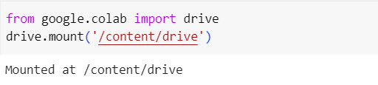
import spacy
import pandas as pd
from spacy import displacy

df=pd.read_csv('/content/drive/MyDrive/mtsamples.csv')
nlp = spacy.load("en_core_web_sm")

# Function to perform NER on a text
def perform_ner(text):
doc = nlp(text)
entities = [(ent.text, ent.label_) for ent in doc.ents]
displacy.render(doc, style="ent", jupyter=True)
return entities

# Apply NER to the entire dataset
df['NER_results'] = df['description'].apply(perform_ner)

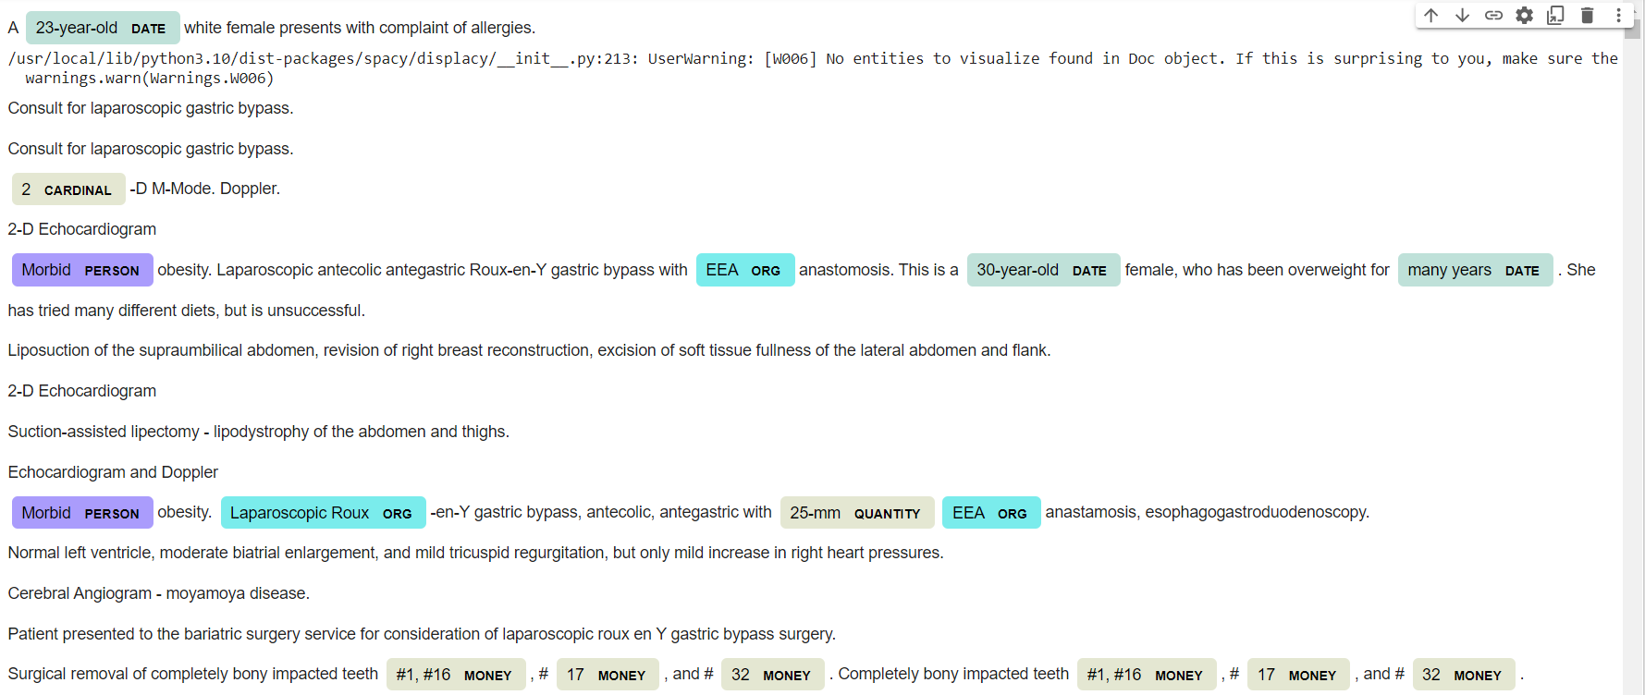
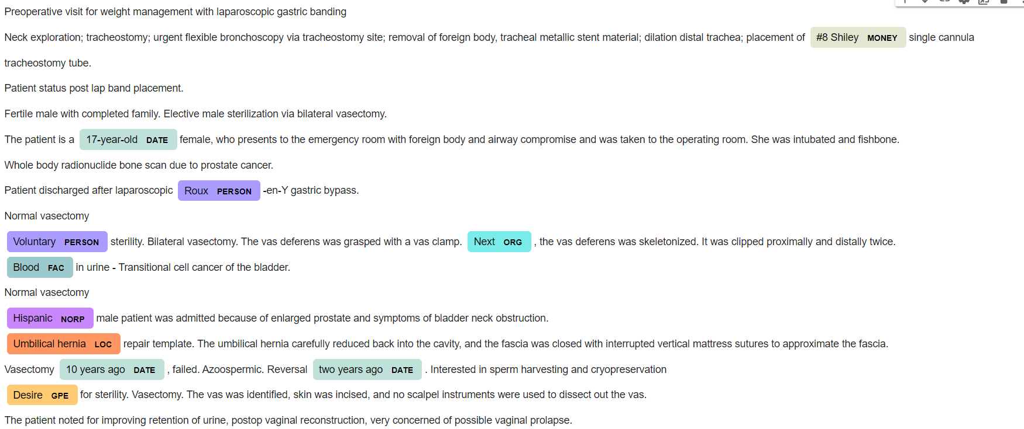

for index, row in df.head(20).iterrows():
print(f"Text: {row['description']}\nNER Results: {row['NER_results']}\n")

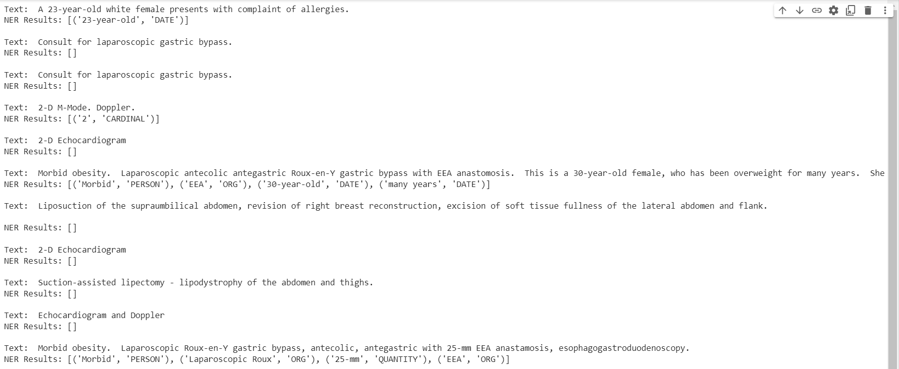

Conclusion (Interpretation of result):

SpaCy’s NER model is avle to retrive different entities with good accuracy. The types of entities retrived are as follows:
PERSON - People, including fictional.
NORP - Nationalities or religious or political groups.
FAC - Buildings, airports, highways, bridges, etc.
ORG - Companies, agencies, institutions, etc.
GPE - Countries, cities, states.
LOC - Non-GPE locations, mountain ranges, bodies of water.
PRODUCT - Objects, vehicles, foods, etc. (Not services.)
EVENT - Named hurricanes, battles, wars, sports events, etc.
WORK_OF_ART - Titles of books, songs, etc.
LAW - Named documents made into laws.
LANGUAGE - Any named language.
DATE - Absolute or relative dates or periods.
TIME - Times smaller than a day.
PERCENT - Percentage, including "%".
MONEY - Monetary values, including unit.
QUANTITY - Measurements, as of weight or distance.
ORDINAL - "first", "second", etc.
CARDINAL - Numerals that do not fall under another type.

But, the spaCy's NER model may not be perfect for medical texts, and you need to fine-tune it on a medical NER dataset for better accuracy.

